Alteplase Administration and Reconstitution Reference

- Obtain accurate patient weight.

- Verify inclusion/exclusion criteria and discuss plan with patient and/or family.

- Verify that administration will start within 4.5 hours of symptom onset or time last known normal.

- Verify SBP less than 185; DBP less than 110 prior to beginning Alteplase.

- Administration:
- 0.9 mg/kg to a maximum of 90 mg
- First 10% of calculated dose as intravenous bolus dose over 1 minute.
- Follow IMMEDIATELY with remaining 90% of calculated dose given as infusion over 1 hour
- When Alteplase bottle is empty, infuse 50mL NS at same rate as Alteplase infusion so all drug in tubing is administered.

- Vital Signs and Neurologic Assessments with Alteplase infusion:
- Q 15 min during infusion and for 1 hour after infusion;
- then every 30 minutes for 6 hours;
- then every 1 hour for 16 hours

- Signs of Intracranial Hemorrhage:
- Acute change in mental or neurological status
- Sudden onset of headache, nausea and/or vomiting
- Sudden elevation in blood pressure and/or bradycardia.

- If intracranial hemorrhage is suspected during the Alteplase infusion, the following actions should be taken:
- Stop the infusion
- Obtain emergent CT

- Watch for signs of adverse reaction:
- Angioedema
- Signs of new bleeding

- Admission to an ICU is required.

- If transporting to another facility, level of care must be preserved. Providers capable of administering anti-hypertensive medications or titrating infusions must be present during transport. It is recommended flight and/or ground transport includes RN staff to maintain consistent level of care.

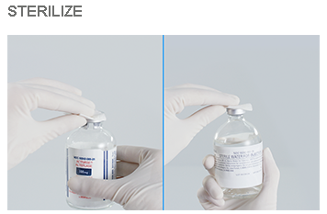
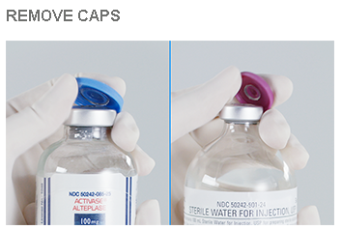
RECONSTITUTION OF ALTEPLASE
Step 1: Remove protective caps and swab the top of each vial with alcohol wipe to reduce the risk of contamination.

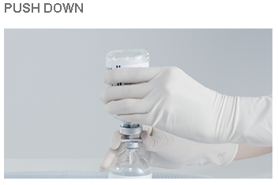
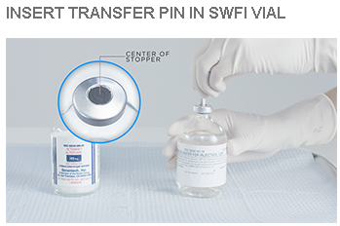
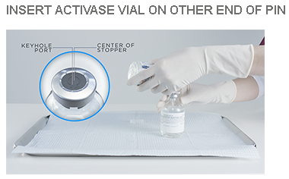
Step 2: Remove one of the protecive caps from the transfer device and insert the piercing pin vertically into the center of the stopper of the Sterile Water for Injection (SWFI) vial, keeping the vial upright. Holding the Activase vial upside down, position it so that the center of the stopper is directly over the exposed pin of the transfer device. Push vial down onto the transfer devise, ensuring that the piercing pin is inserted through the center of the Activase vial stopper.

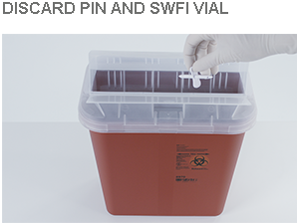
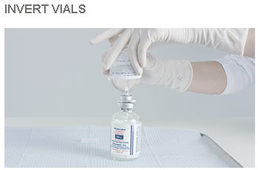
Step 3: Invert the 2 vials, so that the vial of Activase is on the bottom (upright) and the vial of SWFI is upside down. Allow the entire contents of the vial of SWFI to flow down through the transfer device into the vial containing Activase. Aproximately 0.5 mL of SWFI will remain in the diluent vial. Remove the transfer device and the empty SWFI vial from the Activase vial. Safely discard both the transfer device and the empty diluent vial.
Step 4: Mix the solution with a gentle swirl. DO NOT SHAKE. Slight foaming of the solution is normal. Let the solution stand undisturbed for several minutes to allow any large bubbles to dissipate. This preparation will result in a colorless to pale yellow transparent solution containing Activase at a concentration of 1mg/mL. Visually inspect Activase solution for particulate matter and discoloration before administration.May be used within 8 hours of reconstitution when stored between 2-30°C.
